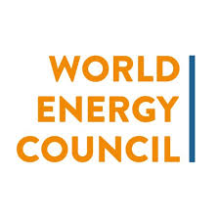

**WEC Global Competition for Start Ups.**

The Start Up Energy Transition (SET) Award is a global competition that identifies the most promising start-ups worldwide working on ideas affecting global energy transition and climate change. The SET Award is accepting applications in 5 categories until 15 January 2020! If you are a start up, apply for your chance to pitch in Berlin at the SET Tech Festival on 24 March, 2020, winners will be featured as a top global start-up with the World Energy Council, win prize money, and more! Previous applicants are highly encouraged to apply again and have their shot at making the annual SET 100 list, which is distributed to SET investors, partners and international public institutions. Apply now: https://bit.ly/2mNTPnZ